* Custom properties in Project level.

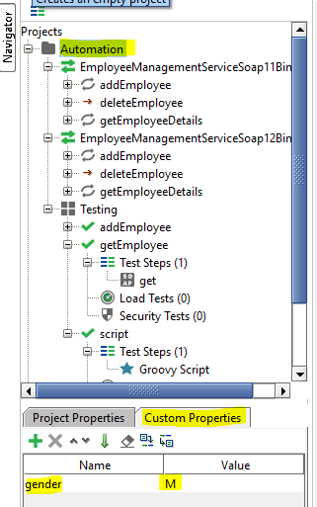

* Ans

def proj=testRunner.testCase.testSuite.project

log.info proj.getPropertyValue("gender")

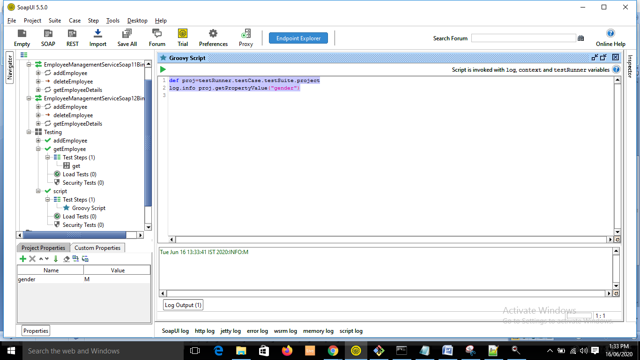

* Hit AddEmployee Request with properties from Test Case level.
* Pull the response stored in test script:

def addReq=testRunner.testCase.testSuite.testCases["addEmployee"].testSteps["add"].getPropertyValue("Request")

* We are going to enter value in soap request.
* There is a class called xml holder while will help to parse your request and enter values inside xml. First we need to import one package to use that xmlholder.

import com.eviware.soapui.support.XmlHolder

* Now create object for XmlHolder class and pass the request inside it.

def xmlAdd=new XmlHolder(addReq)